BillNest – REST API Design
Core API principles (set once, then forget)
- RESTful, resource-based URLs
- JSON request/response
- Stateless
- JWT-authenticated (except auth endpoints)
- Backend is source of truth for calculations
1. Authentication & Users
Why this exists
Users must:
- authenticate
- own data
- belong to groups securely
No system works without this layer.
2. Endpoints
Auth endpoints
1. POST /auth/register – Create a new user account.
Request: name (string), email (string), password (string – hashed)
Response: user_id, access_token ~ “JWT…”
2. POST /auth/login – Authenticate user and return JWT Token.
Request: email, password
Response: access_token
3. POST /auth/forgot-password – Triggers email with reset token.
4. POST /auth/reset-password - Uses token ^ to set new password.
5. GET /auth/me – return authenticated user profile.
User endpoints
1. GET /users/me – Returns authenticated user profile.
Front end bootstrap ~ No guessing user state

Group endpoints
1. POST /groups – Creates group and assigns creator as admin. (name : Malta Trip)
2. Get /groups – Returns all groups the user belongs to. (id, name, role)
3. GET /groups/{group_id} – returns group details + members
Membership endpoints
1. POST /groups/{group_id}/invite – Invites a user by email or invite code.
2. POST /groups/{group_id}/members – Accept invite / add member.
3. DELETE /groups/{group_id}/members/{user_id} – Remove member (admin only)
Expenses endpoints (core intelligence)
1. POST /groups/{group_id}/expenses – Create Expense
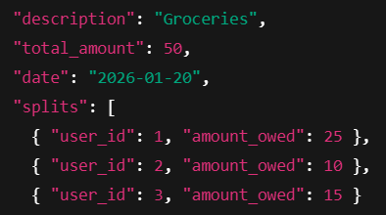
Request:

Rules
- Sum of splits must equal total_amount
- Only group members may appear in splits
Backend responsibilities:
- sets created_by = current_user
- validates splits sum
- stores expense + splits
Frontend never calculates balances
2. GET /expenses/{expense_id} – Returns full detail: payments, splits, participants.
3. DELETE /expenses/{expense_id} – Delete / edit expense (admin only)

Derived balances endpoints
Balances are:
- derived data
- never stored
- recalculated on demand
This avoids corruption.
1. GET /groups/{groip_id}/balances – Group balances (positive = owed money, negative = owes money)
2. GET /groups/{group_id}/settlements – Settle up what you owe in the group.
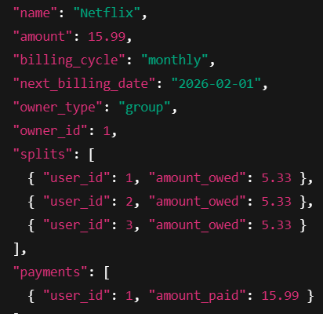
Subscription endpoints
1. POST /subscriptions -

2. GET /subscriptions – Returns all the subscriptions that the user is involved in (private or group)
3. GET /subscriptions/{subscription_id} – Full detail for that sub + next renewal.
Subscription renewal – System driven
1. POST /subscriptions/run-renewals – Finds subs due. Generates expenses, Links via GeneratedExpense.

Dahsboard endpoints
1. GET /groups/{group_id}/summary – Total spent, per-user contributions, subscriptions vs one-off
2. GET /users/me/subscriptions/summary – monthly recurring total, yearly recuring total
Settlements endpoints
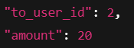
1. POST /groups/{group_id}/settlements – I claim I’ve paid this person £x

2. POST /settlements/{settlement_id}/confirm
3. POST /settlements/{settlement_id}/reject
Design Notes
- The system does not process payments
- Settlements are trust-based confirmations
- All balances are derived, never stored
- Single-payer expense model keeps logic simple and predictable

